/*Ashok IPBC - Building a Cube Lab 8.12.19*/

Homework – Please complete the following steps…

1. Create a cube using Mortgage Project Story-6 Fact and Dimension tables. First make sure your

Primary Key / Foreign Key relationships have correctly been defined on the tables.

a. Dim_Borrower

b. Dim_Loan

c. Dim_Property

d. Fact_Financials

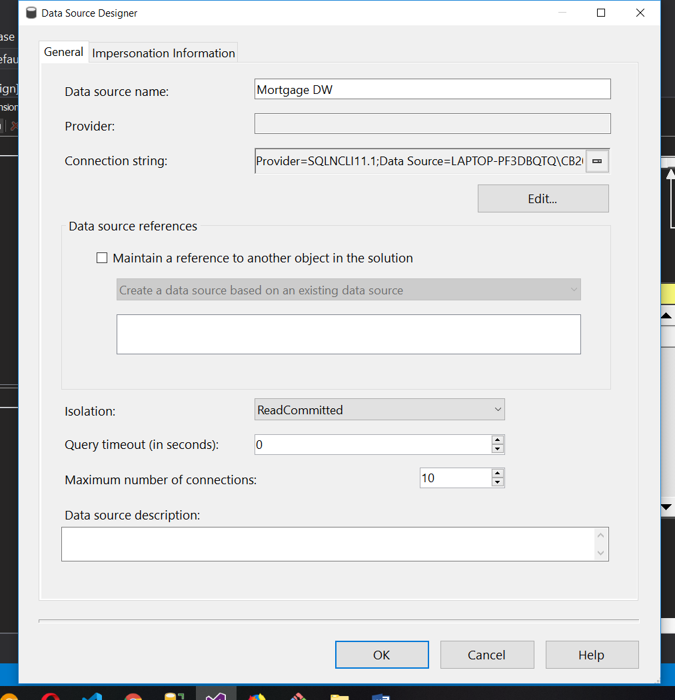

Let’s create Mortgage DW data source with using existing tables from data warehouse dimensions and facts.

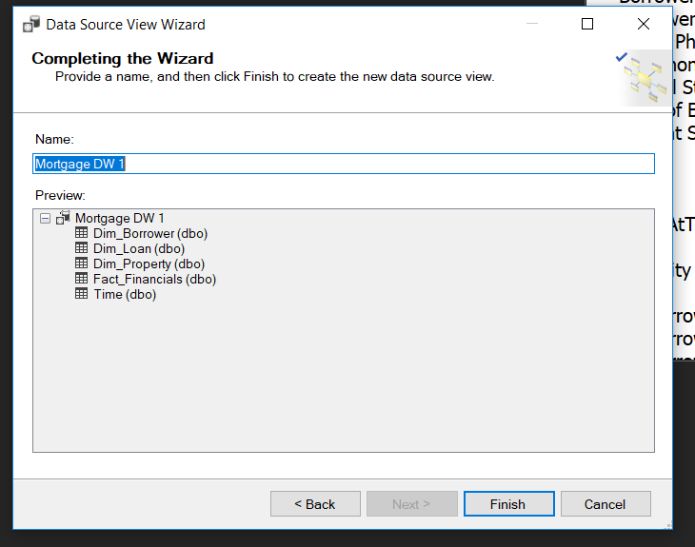

Now we create data source view with help of available Dimensions and facts

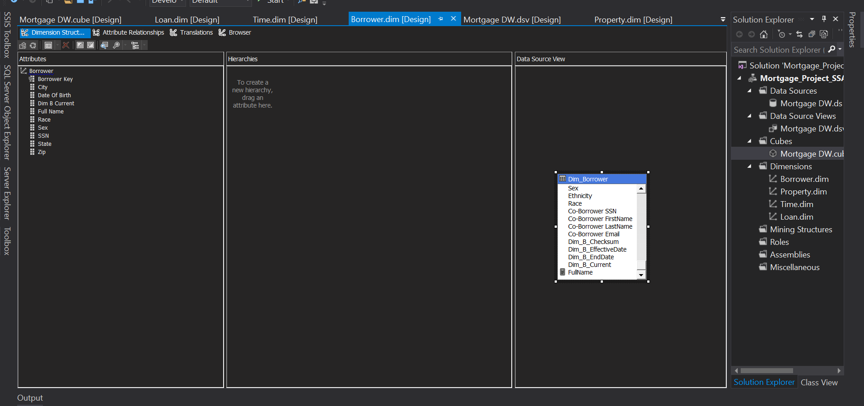

Now we need to create a  dimensions as a borrower with the help of existing  borrower dimension in data warehouse

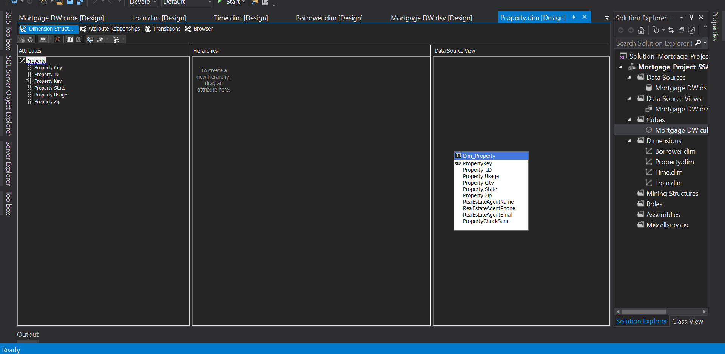

Also we created property Dimension with the help of existing dimension in data warehouse

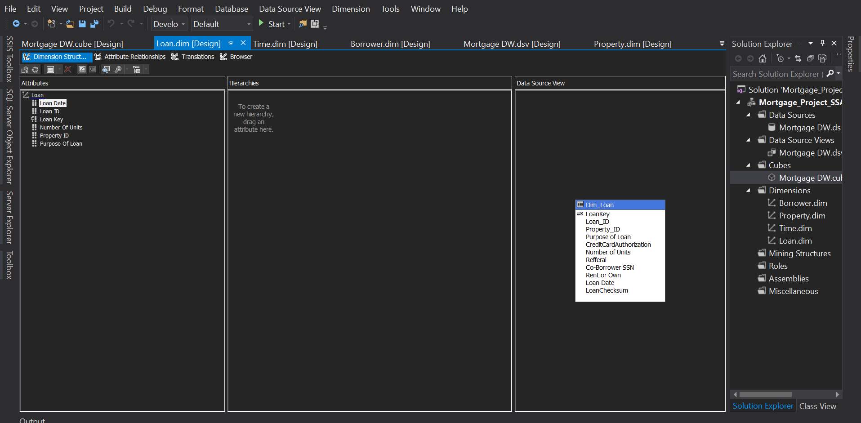

Recreate the lawn dimension good to help existing dimension from a SQL data warehouse database

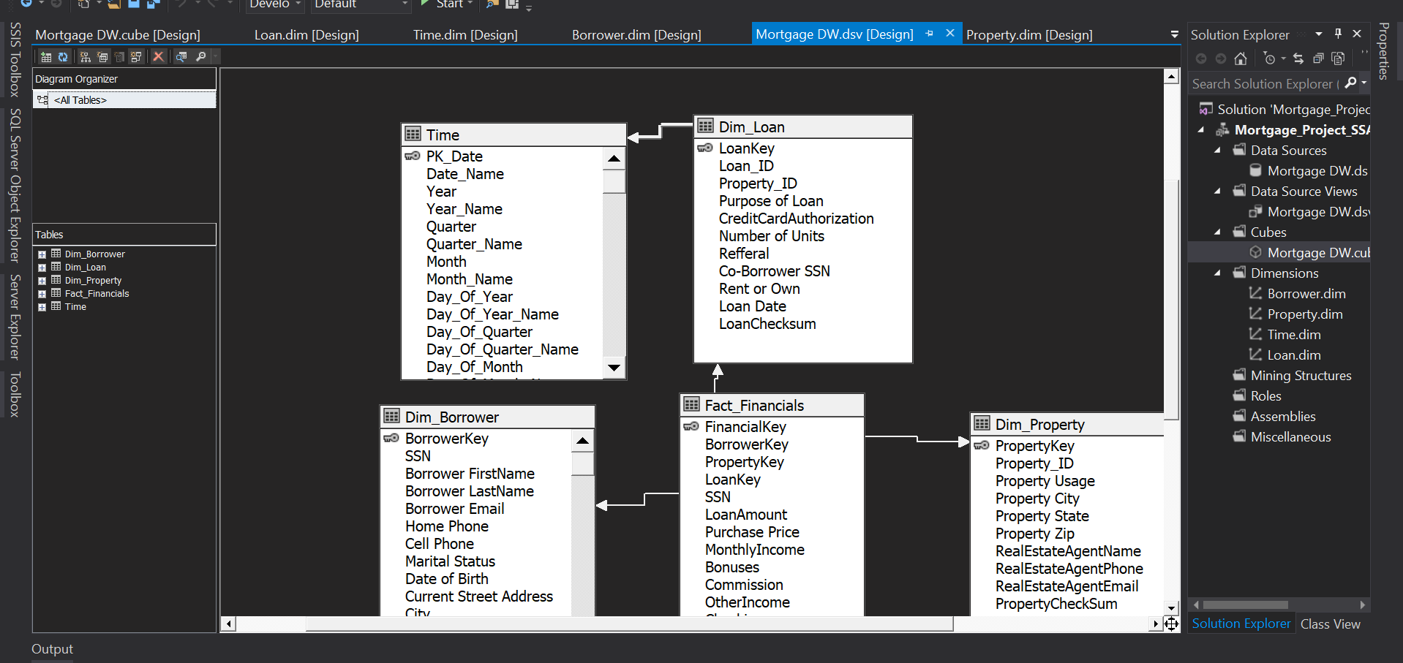

Now we create the cube with the help of all dimensions baby can see our Dimension borrower lawn property and time they are connected with foreign key and primary keys

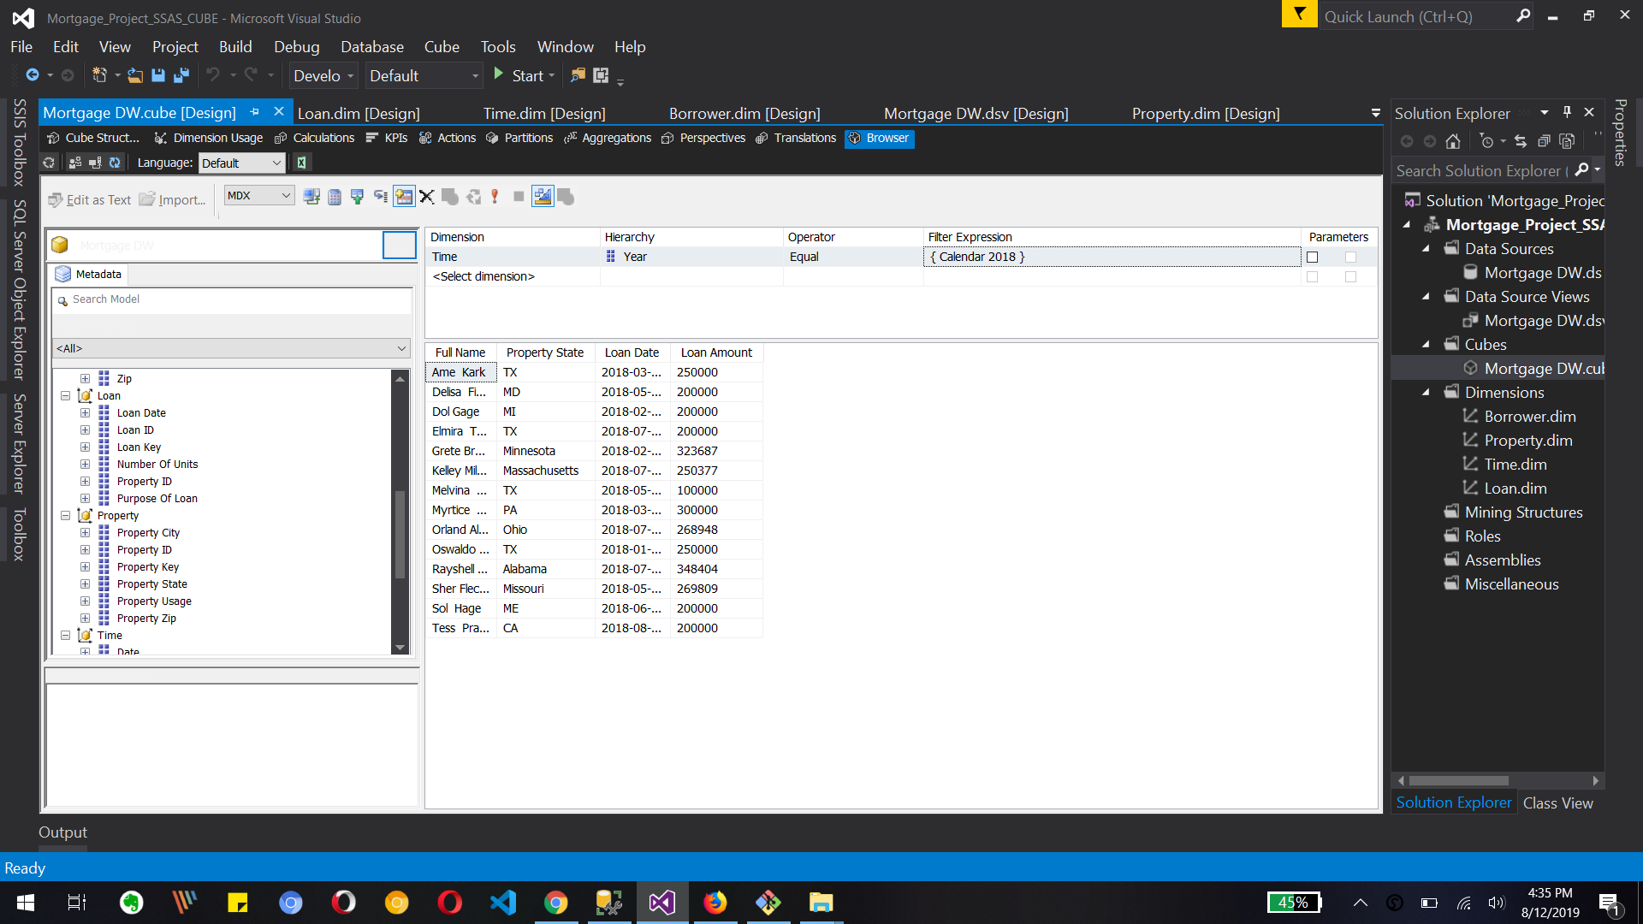

 the image soles browser tab of our created Cube where we can see measures and different dimensions also we can use the calculated column in our query editor with drag and drop

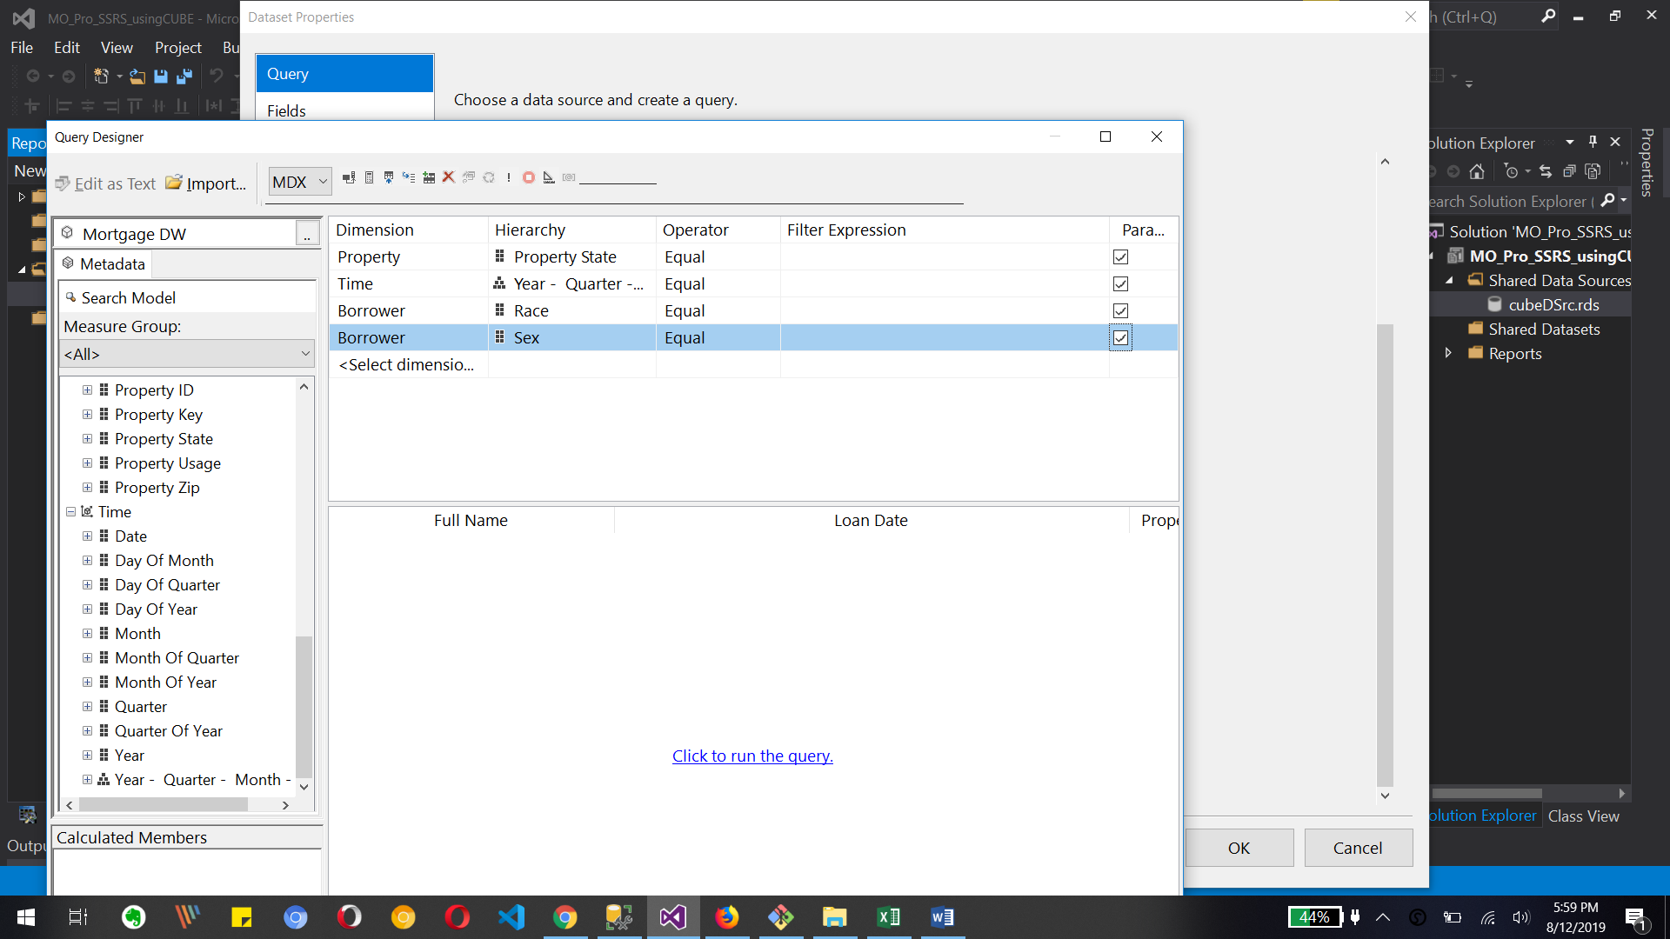

Here we can use the parameters as we can see different race sex year quarter property State as we define parameter and we can run the query based on that filters/ parameters

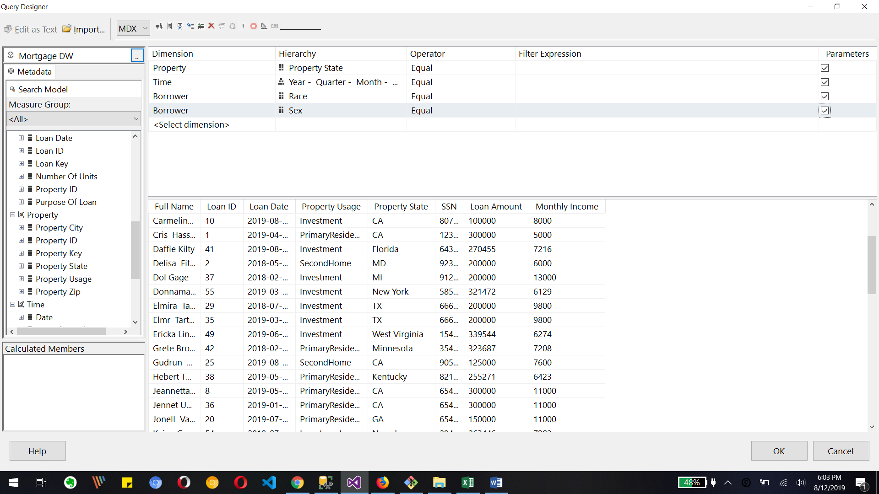

Once we Define the word query columns any fees run over query then we can see the output with all related columns as a full name law and ideal owned a property usage and monthly income

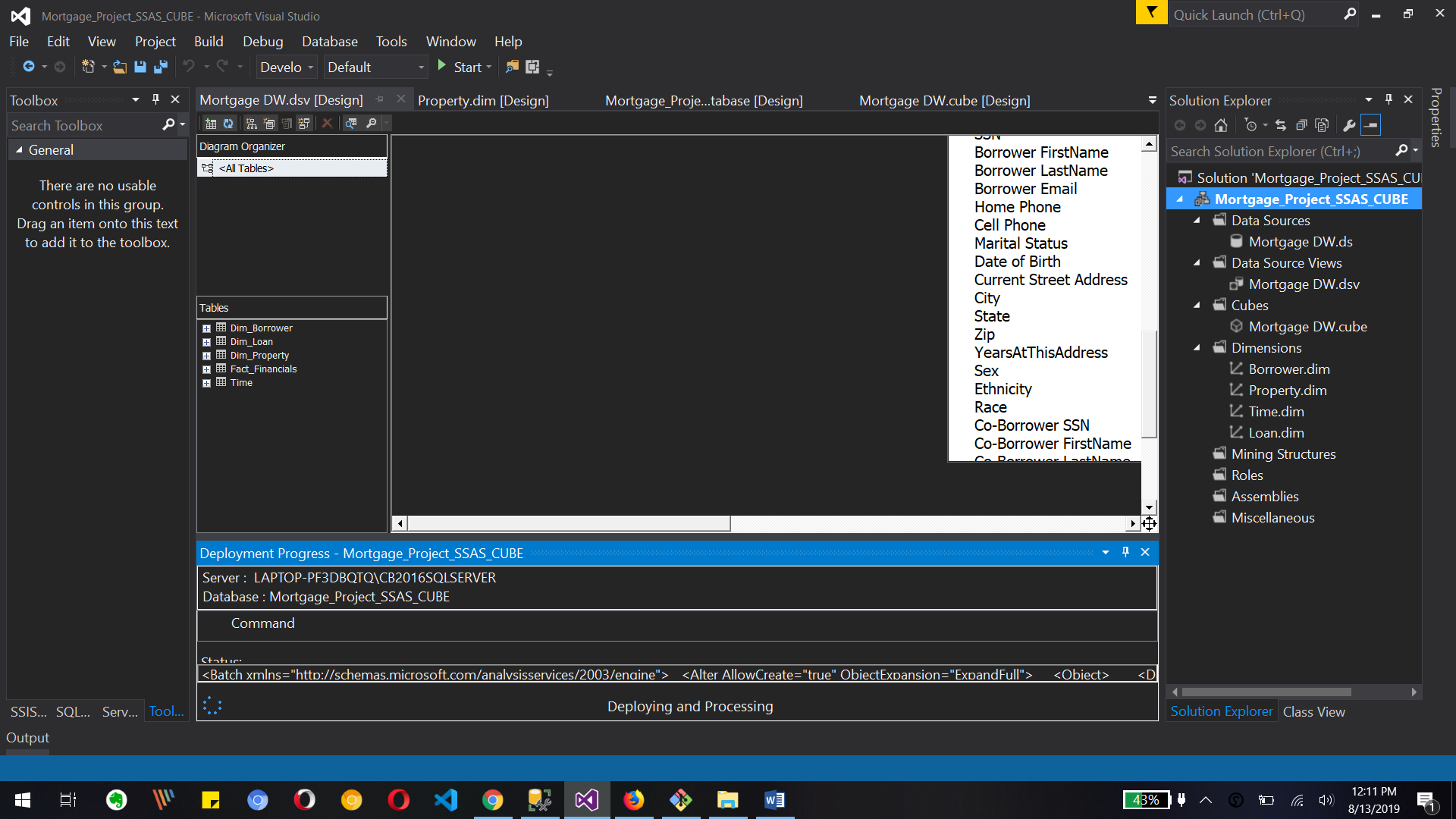

Let's process the cube we can see the deployment and processing is going on

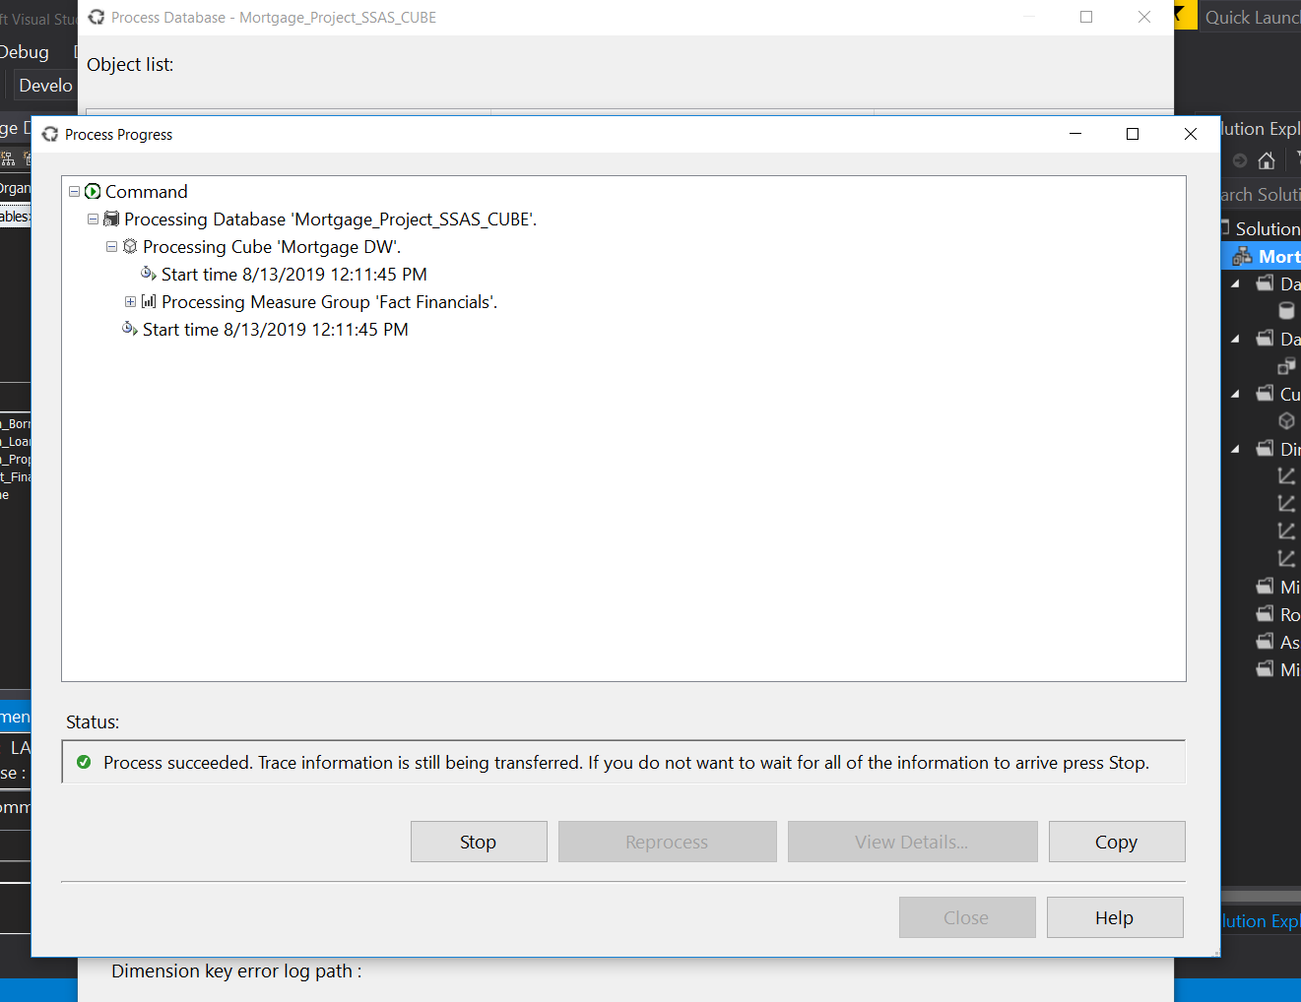

Finally we can see the deployment of the cube has been completely successful

2. Create a time dimension based on the Loan Date (Link them with the Cube Attributes)

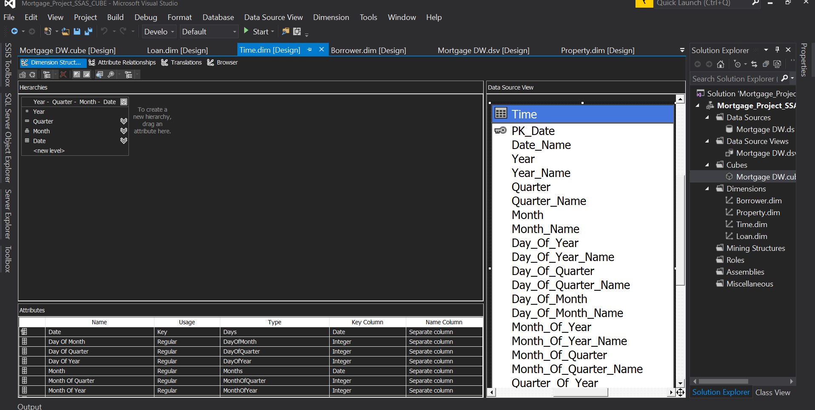

This is the time Dimension which we created with the help of ssas verity got your month water in different related columns in that with one primary key as date

3. Create a Hierarchy on the Time Dimension

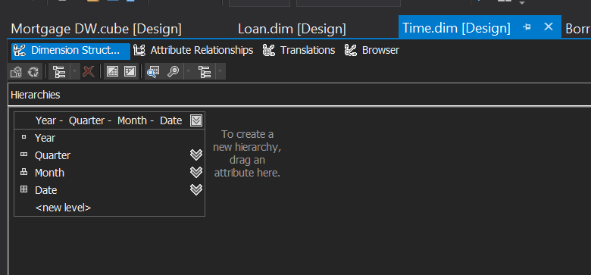

This is the hierarchy of time Dimension where we have a year then water than month and then date so we can get the data as a example 2019 quarter 2 month of August and today's date

4. Process the Cube



Once we created the time Dimension we can process the key good with the help of all other dimension and time Dimension and also with the facts which is stored in our data warehouse

5. Build an SSRS Report on the cube – Be creative and build something visually appealing. Use the

Time Dimension as a Parameter in your report. 

We create the report as we usually created but the main part is creating the data set where we can use the cube data and we can get the Define parameters and the different columns

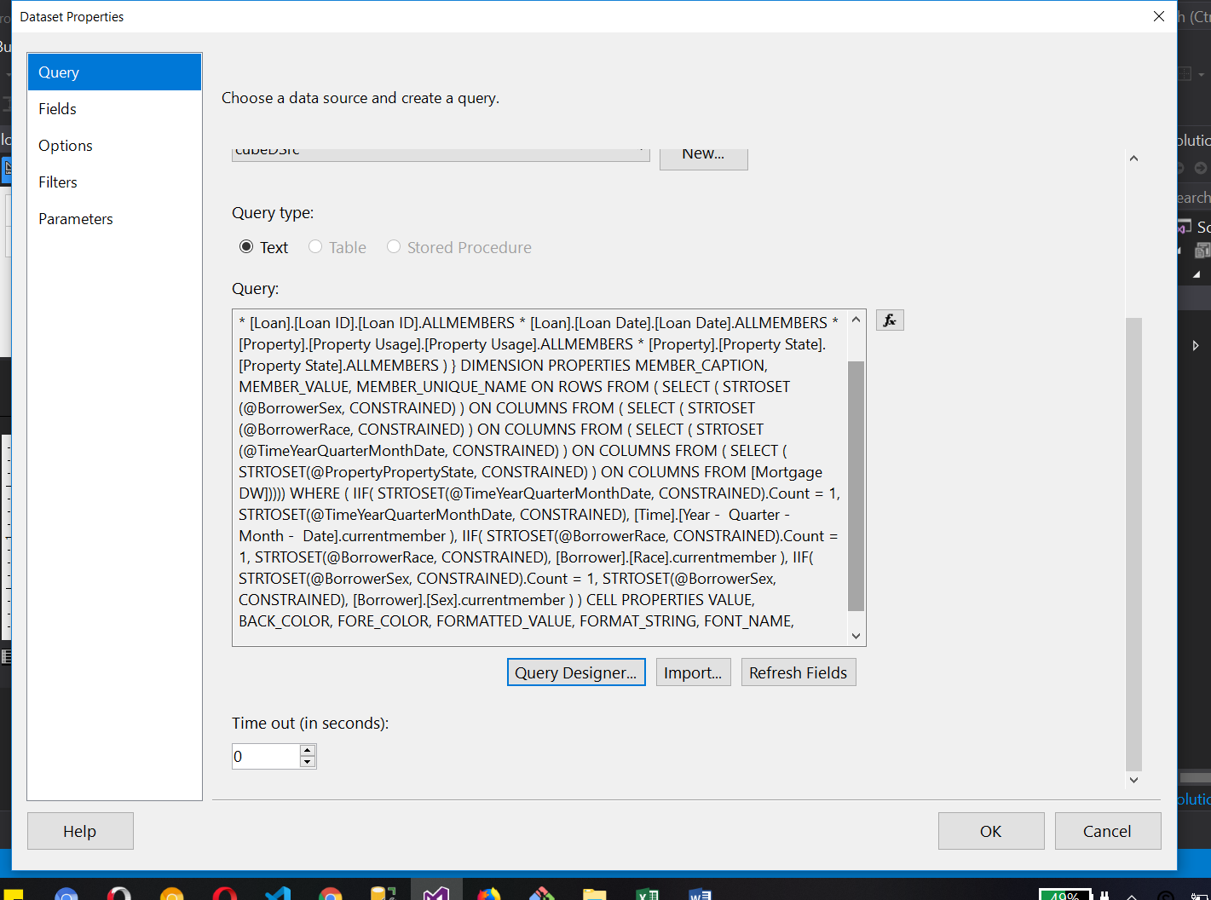

We can see the data set property and in query we can see the auto created SQL query Buy credit designer where we use Cube data and columns

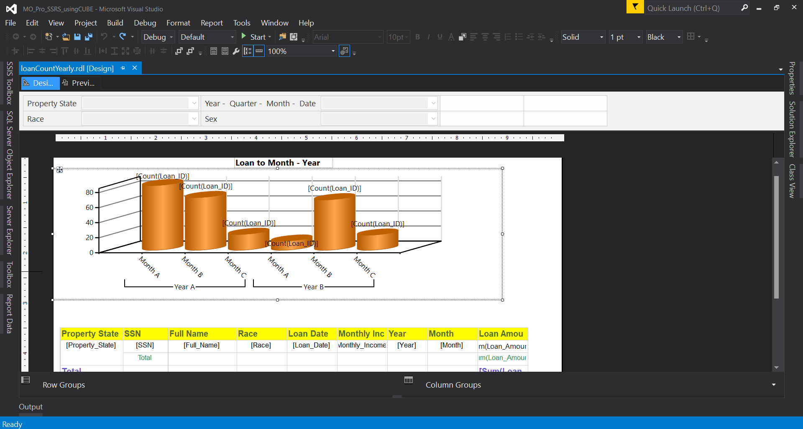

This is lawn to month and your count chart where we can see e someone a 3D loan barchart

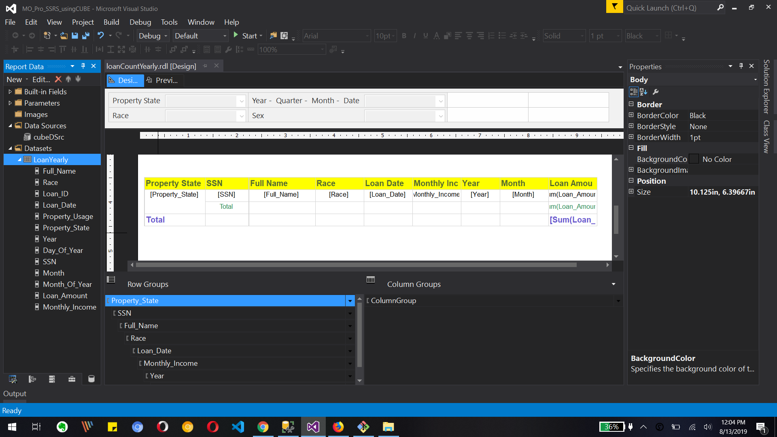

This is Matrix which is created as a part of rapport with a subtotal and grand total for state wise loan amount

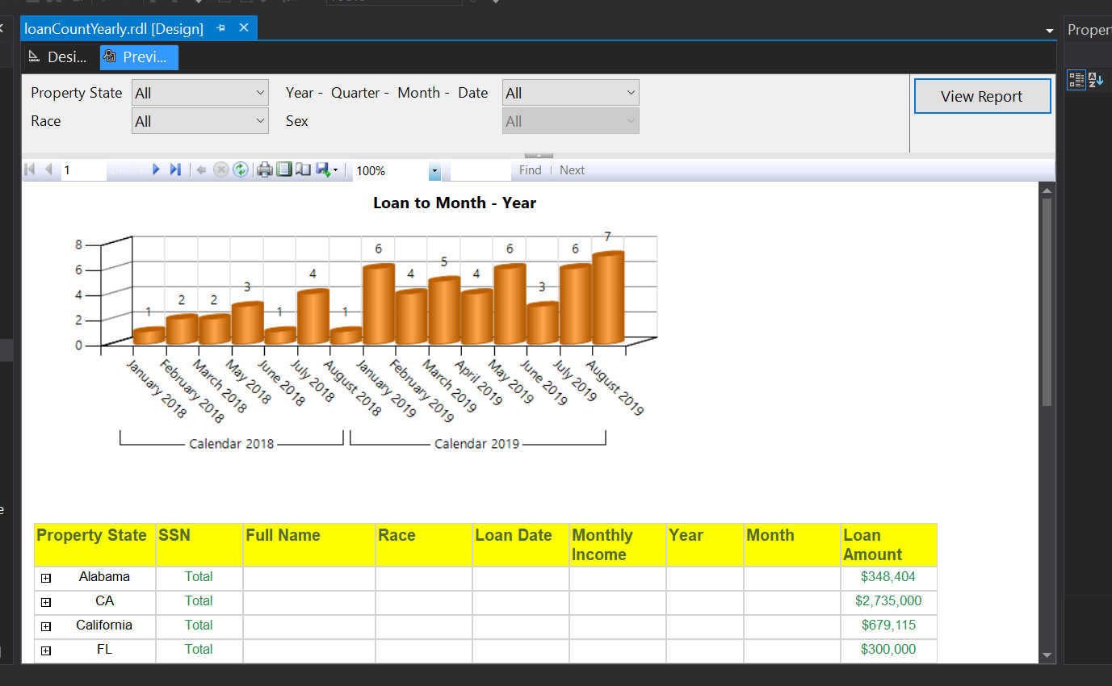

This is the output of a bar chart and Matrix where we can see laundromat by your count and also the state wise loan amount with different detail and visibility based on state.

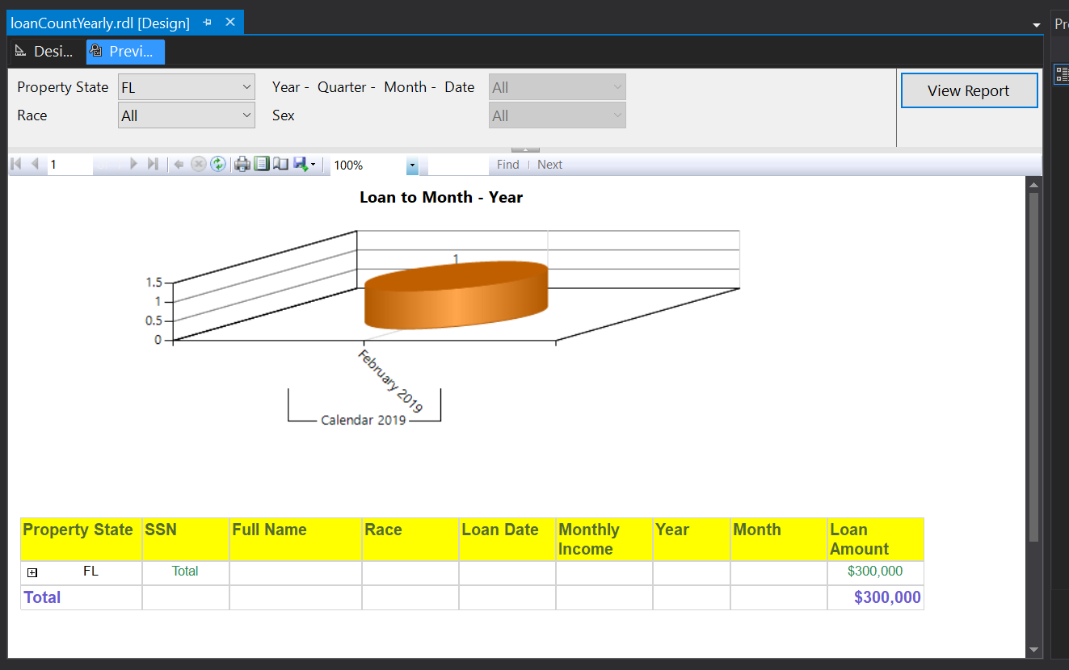

Yet I have applied the filter as a property states that are Florida and we can see the change in a bar chart and matrix

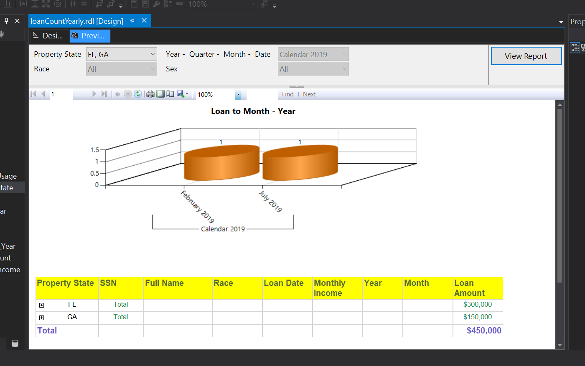

Parameter State and year has been changed and we can see their reflection in our report

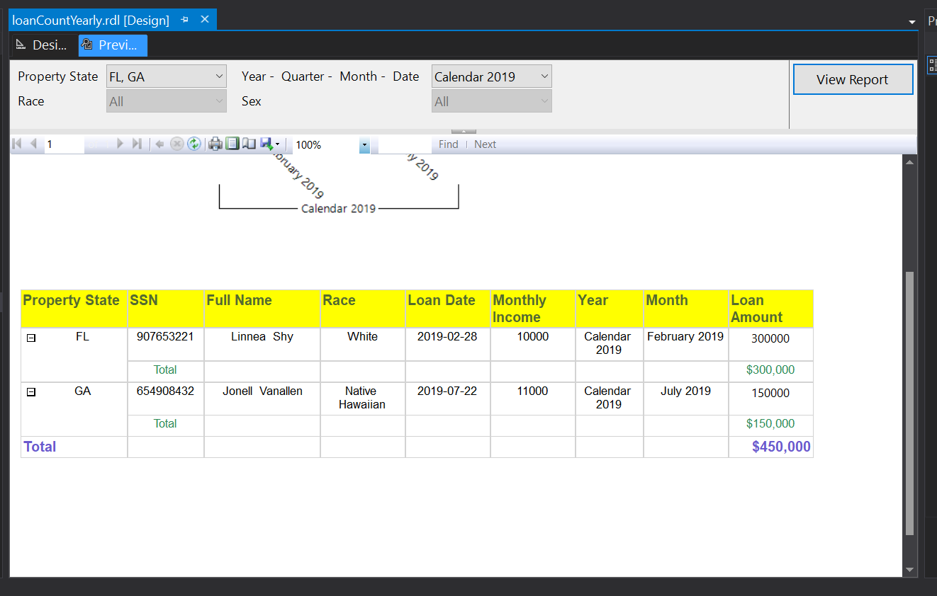

This is visibility for state parameter Florida, Georgia and parameter year 2019, we also see their subtotal and final grand total of loan amount for both State

What to Submit:

1. Copy and paste the link to your video(s) as part of your homework..
   1. SQL BI Interview Questions: SSAS – What are FACT and DIMENSION tables

<https://app.colaberry.com/app/ipbc/videos?user=31221&category=51>

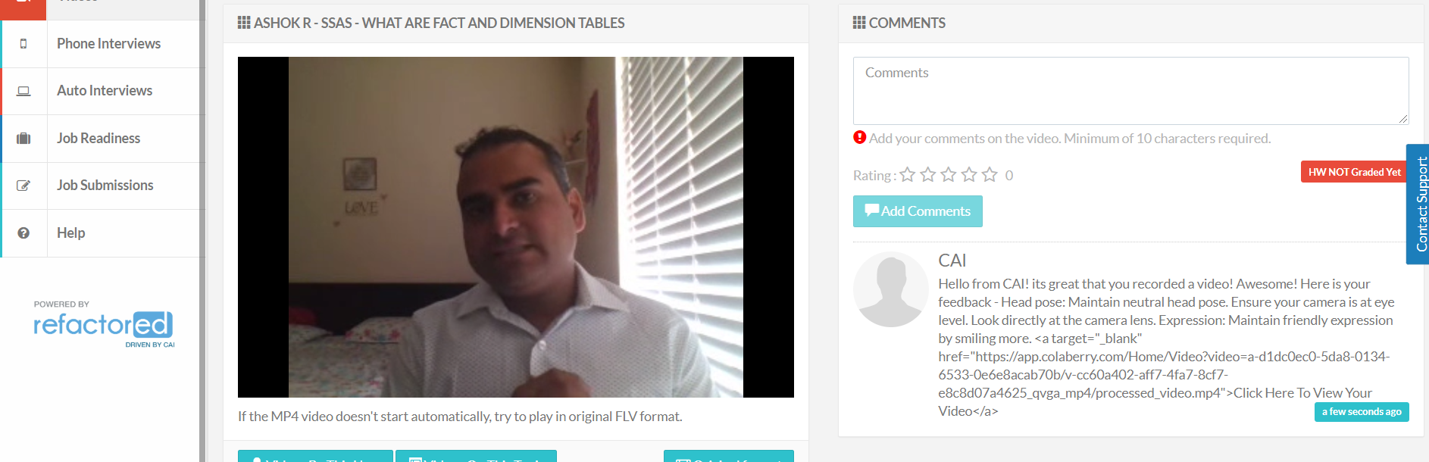

* 1. SQL BI Interview Questions: SSAS – What is a cube

<https://app.colaberry.com/app/ipbc/videos?user=31221&category=53>

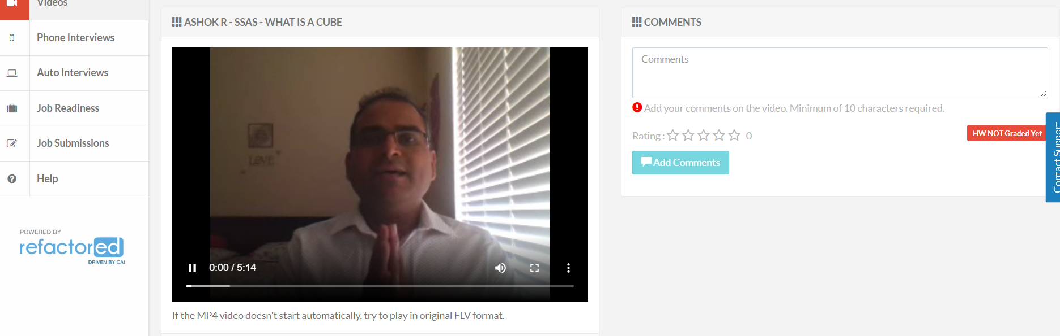

2. Watch, Comment &amp; take screenshots of your comments from 3 other videos on the same

topic (per question). Comments must be 20+ characters. Leave comments based on

presentation, delivery and/or technical details. Your critiques will help you be more

conscious of your own videos. (3 comment screenshots per Video Question)

* + SQL BI Interview Questions: SSAS – What are FACT and DIMENSION tables

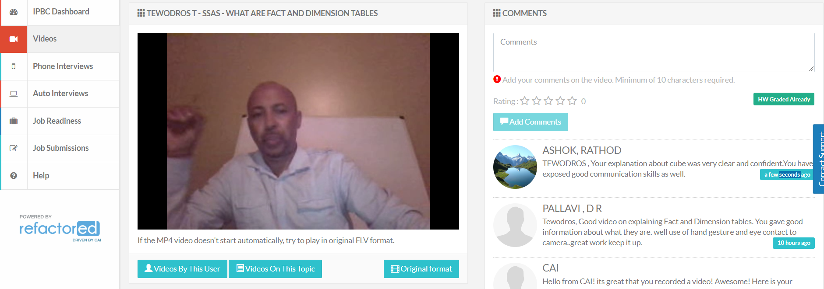

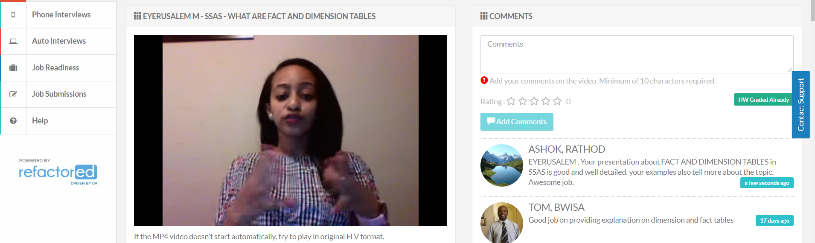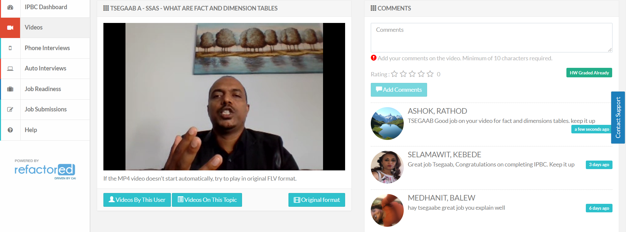

* + SQL BI Interview Questions: SSAS – What is a cube

